Suricata IDS/IPS Setup Project – Step by Step Guide

Project Overview
This project demonstrates how to deploy and test a Network Intrusion Detection System (IDS) and Intrusion Prevention System (IPS) using Suricata on an Ubuntu virtual machine. A Kali Linux VM is used to generate attack traffic to verify detection using Nmap and simulate a DDos attack.

Lab Environment
- Ubuntu VM (Suricata)
- Kali Linux VM (Attacker)
- VirtualBox network: Nat Network
- Ubuntu IP: 10.0.2.4
- Kali IP: 10.0.2.15
- Network range: 10.0.2.0/24

Step 1: Update the Ubuntu system
Terminal command:
- sudo apt update
Explanation:
Updates the Ubuntu package list so the latest Suricata packages can be installed.

Step 2: Install Suricata
Go to Website: https://suricata.io/
Hit the 3-line button at top right corner -> Documentation -> Users -> Installation guide.
-scroll down to Ubuntu
Install the dependencies with Sudo privileges:
Terminal command:
sudo apt -y install autoconf automake build-essential cargo \
cbindgen libjansson-dev libpcap-dev libpcre2-dev libtool \
libyaml-dev make pkg-config rustc zlib1g-dev

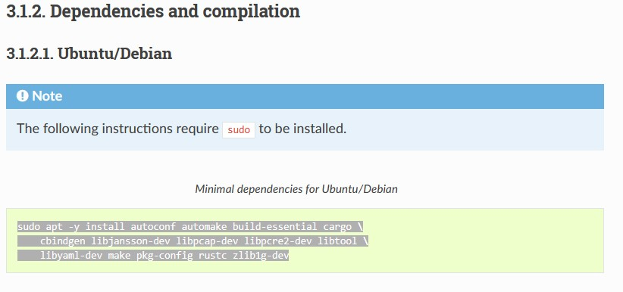
-then continue to scroll down to Binary packages. Click on Ubuntu Package Installation. Follow the download guide
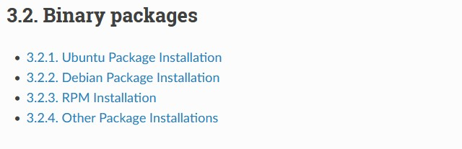
Terminal command:
sudo apt-get install software-properties-common

sudo add-apt-repository ppa:oisf/suricata-stable

sudo apt-get update

Then, you can install the latest stable with:

sudo apt-get install suricata

After installing you can proceed to the Basic setup.

Explanation:
Installs Suricata IDS and all required dependencies.

Step 3: Verify installation
Terminal command:
- suricata -V
Explanation:
Confirms Suricata is installed and shows the version number.

Step 4: Identify network interface
Terminal command:
- ip addr
It should look like something like this:
$ ip addr

2: enp1s0: <BROADCAST,MULTICAST,UP,LOWER_UP> mtu 1500 qdisc fq_codel state UP group default qlen 1000
link/ether 00:11:22:33:44:55 brd ff:ff:ff:ff:ff:ff
inet 10.0.0.23/24 brd 10.23.0.255 scope global noprefixroute enp1s0
you are looking for the heighted portion after the “2:” and “inet”.
In this scenario it’s:
2: enp1s0 inet 10.0.0.23/24
Explanation:
This displays the IP address of the network. The active interface is usually named enp0s3, as it was in my lab

Step 5: Edit Suricata configuration file
Terminal command:
- sudo nano /etc/suricata/suricata.yaml
Explanation:
Opens Suricata’s main configuration file to define the protected network.
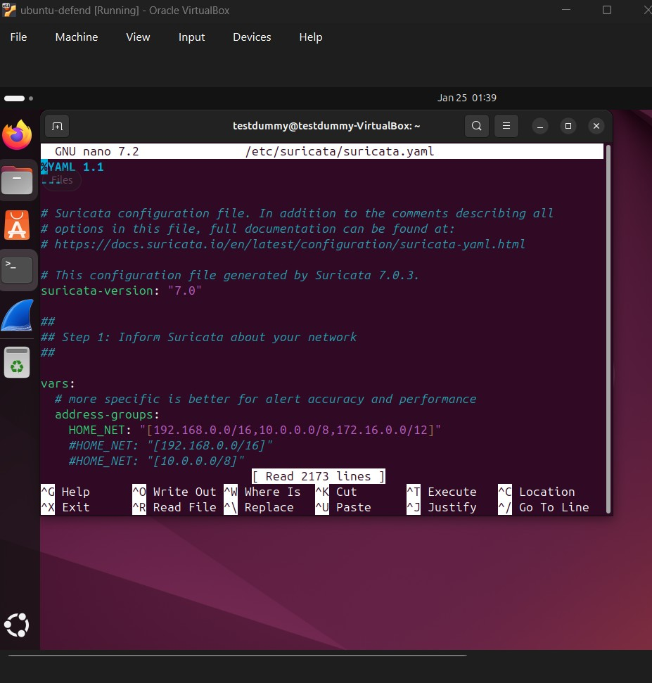

Step 6: Edit Suricata configuration file
Terminal command:
sudo nano /etc/suricata/suricata.yaml
Find: HOME_NET
Inside the file, find this line:
HOME_NET: "[192.168.0.0/16]"
Change it to:
HOME_NET: "[INSERT YOUR NETWORK RANGE]"
Explanation:
This tells Suricata what your protected network is
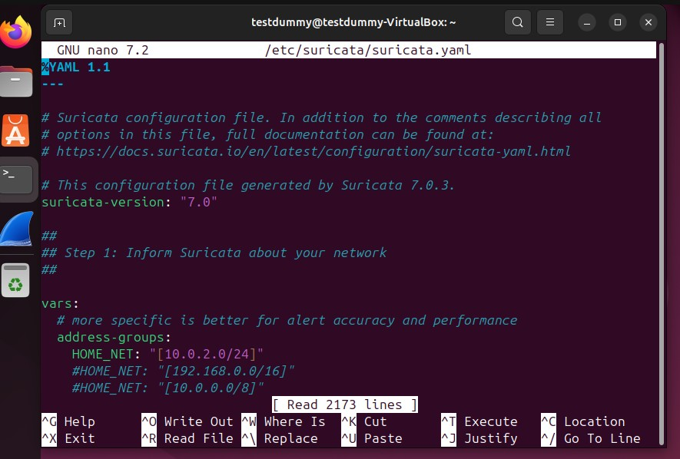

Find: af-packet:
af-packet:
- interface: enp1s0
cluster-id: 99
cluster-type: cluster_flow
defrag: yes
tpacket-v3: yes

-Change interface to the enp0s3 from earlier.
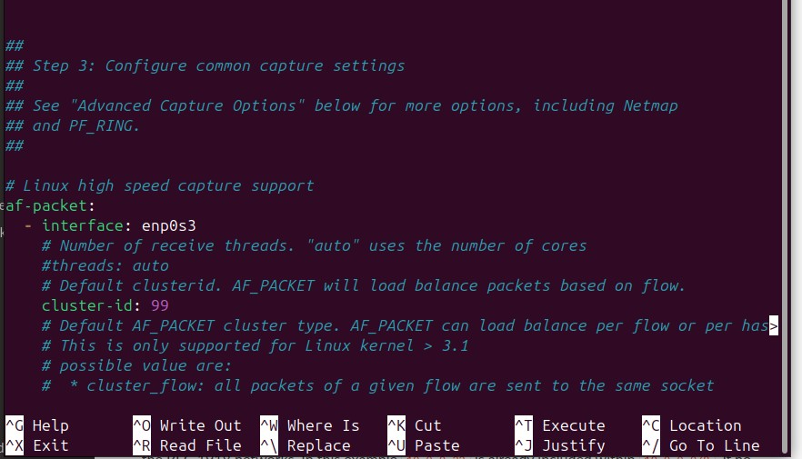
Find pcap. Change to enp0s3
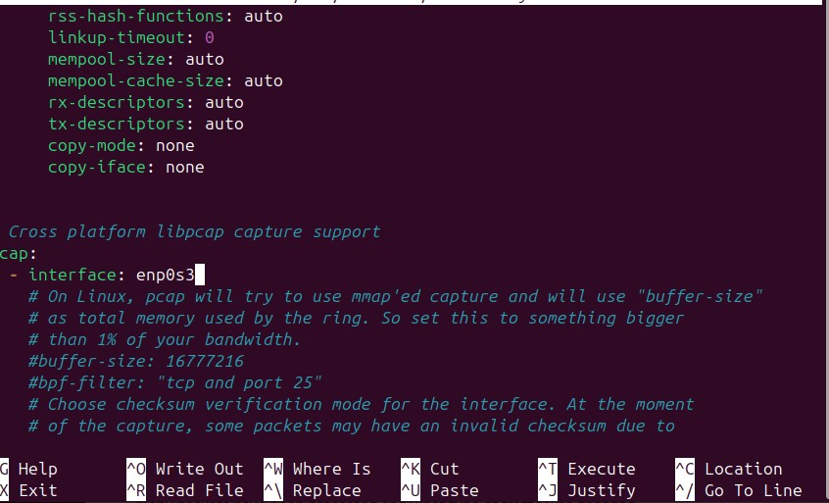
Save and exit:
CTRL + O, Enter, CTRL + X

Step 7: Download detection rules
Terminal command:
- sudo suricata-update
- sudo suricata-update list-sources
(optional): shows list of community rules. Check for MIT or Open Source next to License.
- Example: sudo suricata-update enable source (insert Name of the source)
- sudo suricata-update

Explanation:
Downloads community rules used to detect scans and malicious activity.

Step 8: Start Suricata in IDS mode
Terminal command:
- sudo suricata -i enp0s3
or:
- sudo suricata -c /etc/suricata/suricata.yaml -i enp0s3
- Explanation:
Runs Suricata in live IDS mode and begins monitoring network traffic.
The terminal will appear idle because Suricata is waiting for traffic. Monitors traffic on network interface enp0s3. All alerts are being written to log files, not displayed on screen.

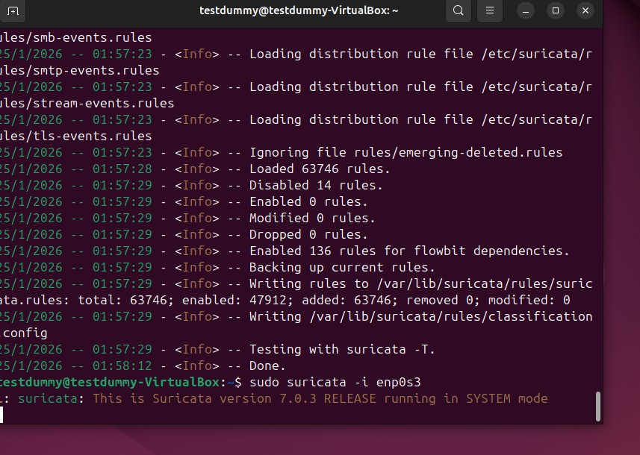

Step 9 — Open a new terminal to watch alerts
On the same Ubuntu IDS VM, open a second terminal and run:
sudo tail -f /var/log/suricata/fast.log
Explanation:
- tail -f = follow the log live
- fast.log is where Suricata writes alerts in real time
- This is where you’ll see the ICMP and nmap scan alerts

While Suricata is running:
- From Kali VM, generate network traffic to test detection:
  - Run an Nmap scan: nmap -sS 10.0.2.4
  - Ping the Ubuntu VM: ping 10.0.2.4 (press CTRL + C to stop)
  - Access services on Ubuntu VM (HTTP, SSH, etc.)
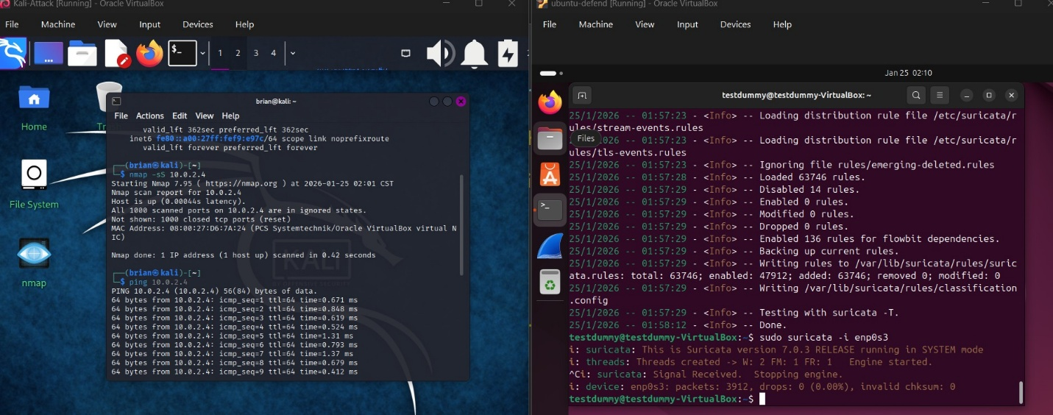
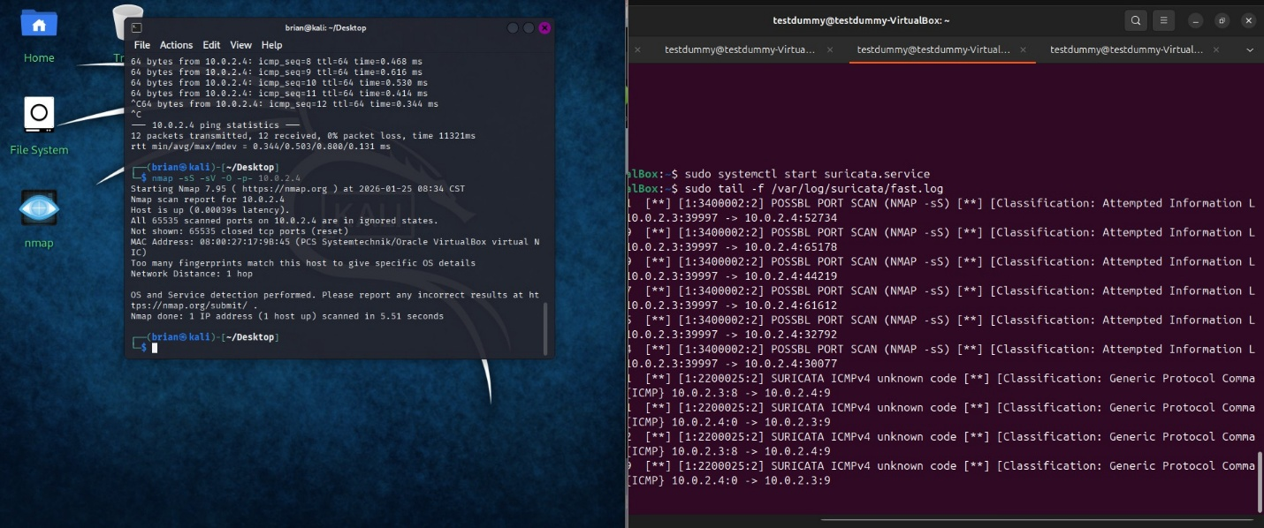
Note: The terminal idle state is normal. Suricata is actively working in the background.

How to stop Suricata:
Press CTRL + C in the Ubuntu terminal.
- Stops the IDS process safely
- Returns you to the prompt
- Shows packet and alert statistics

(OPTIONAL) Convert IDS into IPS and Perform A DDoS Attack.

Step 1: Open the Suricata configuration file
sudo nano /etc/suricata/suricata.yaml
This command opens Suricata’s main configuration file using the nano text editor with administrator privileges. You need sudo because this file is protected by the system. This file controls how Suricata runs and which packet capture method it uses.

Step 2: Disable AF-PACKET (IDS mode)
Inside the file, find the section that looks like this:
af-packet:
- interface: enp0s3
- cluster-id: 99
- cluster-type: cluster_flow
- defrag: yes
Change it to:
# af-packet:
# - interface: enp0s3
#- cluster-id: 99
# - cluster-type: cluster_flow
# - defrag: yes

This change buy adding the “#” to the beginning comments out the AF-PACKET capture method. AF-PACKET is used for IDS mode only. IPS mode requires NFQUEUE instead, so this prevents Suricata from listening in passive mode

Step 3 — Enable NFQUEUE (IPS capture)
In the same file, find or create the section:
nfqueue:
- id: 0
accept-mark: 1
fail-open: yes
batchcount: 20
mode: accept
threads: auto

This tells Suricata to read packets from Linux NFQUEUE number 0. The fail-open: yes option ensures that if Suricata crashes, traffic still passes instead of being blocked. Tip: Always use fail-open: yes in lab or production to avoid network outages during testing.
Save and exit nano using CTRL+O, Enter, CTRL+X.
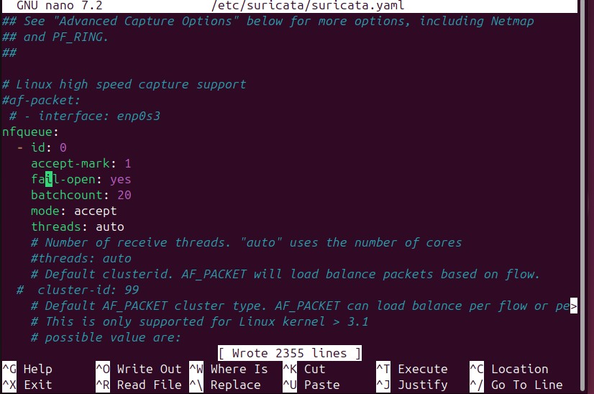

Terminal command:
sudo systemctl edit –full suricata.service

Under [Service] look for: –af-packet
Delete and add: -q 0
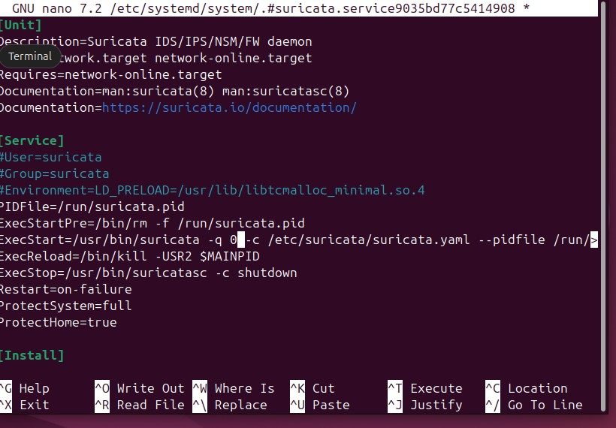
Save and exit nano using CTRL+O, Enter, CTRL+X.

Step 4 — Create your custom rules folder
sudo mkdir /var/lib/suricata/rules/mycustomrules
This command creates a new folder inside Suricata’s rules directory with the exact name you chose, which I indicated in pink font. This folder will hold all your custom IPS rules.

check what folders exist in Suricata’s rules directory.
Type this:
sudo ls /var/lib/suricata/rules
Look at the output. If you do NOT see your custom folder there, then it was
Now recreate the folder correctly.
Use this:
sudo mkdir /var/lib/suricata/rules/ mycustomrules
Now verify it exists:
sudo ls /var/lib/suricata/rules
You should now see:
mycustomrules
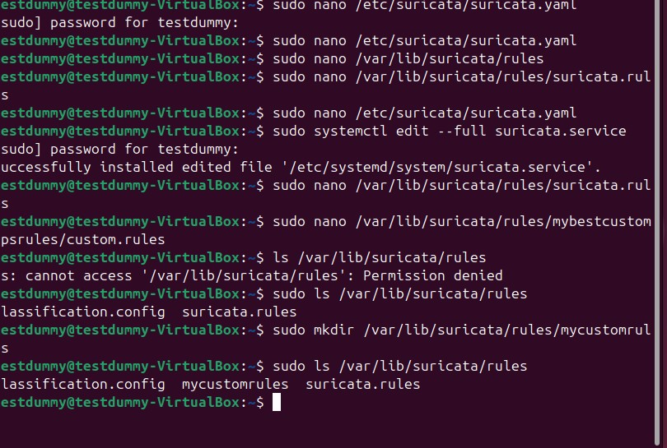

Create a custom rules file inside your folder
sudo nano /var/lib/suricata/rules/mycustomrules/custom.rules
This command creates a new file called custom.rules inside your custom folder and opens it in the nano text editor. You can replace custom.rules with any filename you want, but the .rules extension is required for Suricata to recognize it. This is where you will write your custom rules for your lab.

Step 4c — Add a sample custom rule
Inside the custom.rules file, type:
drop icmp any any -> $HOME_NET any (msg:"Custom ICMP Block Message"; sid:2000001; rev:1;)
This rule instructs Suricata to block ICMP (ping) traffic. drop actively blocks the packet instead of just logging it. The msg: is the message that will appear in the log file when this rule triggers. sid is a unique rule ID — you can number your rules in the 2000000+ range for your custom folder. rev is the revision number of the rule.
After typing, save and exit nano with CTRL+O, Enter, CTRL+X.

Verify the rule file exists
Type:
ls /var/lib/suricata/rules/mycustomrules
You should see:
custom.rules
This confirms the folder and rule file were created correctly.

Step 4d — Check the contents of the rule file
Type:
cat /var/lib/suricata/rules/mycustomrules/custom.rules
You should see your rule printed on the screen. This confirms Suricata will be able to read it.

Step 5: Add your custom rules file to Suricata’s configuration
sudo nano /etc/suricata/suricata.yaml
This opens Suricata’s main configuration file. Suricata will not load your custom rule unless it is listed here.
Inside the file, find the section called rule-files: and add this line under the existing entries:
- mycustomrules/custom.rules
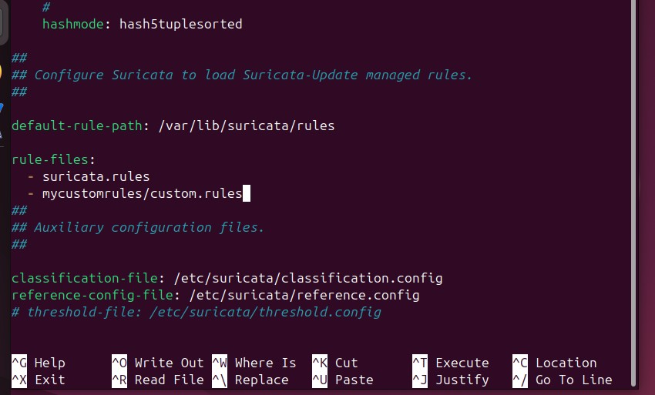
This tells Suricata to load your custom rules file along with the default rules.
Save and exit with CTRL+O, Enter, then CTRL+X.

Step 6 — Test the Suricata configuration
sudo suricata -T -c /etc/suricata/suricata.yaml
This command checks your configuration and all rule files for errors without starting Suricata. If everything is correct, you should see a message saying the configuration is valid and rules were loaded successfully.
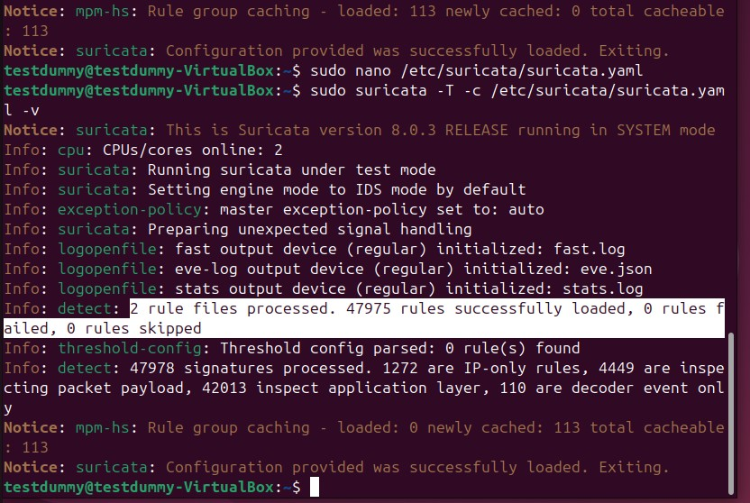

Step 7 — Add iptables rule for IPS (NFQUEUE)
sudo iptables -I INPUT -j NFQUEUE --queue-num 0

sudo iptables -I OUTPUT -j NFQUEUE --queue-num 0

This sends incoming network traffic to Suricata for inspection. Without this step, Suricata cannot block traffic and will only act as an IDS.

Step 8 — Check iptables status
sudo iptables -L
This displays all firewall rules. You should see an entry for NFQUEUE, confirming traffic is being redirected to Suricata.

Step 9 — Check for AF-PACKET is still enabled

sudo systemctl status suricata

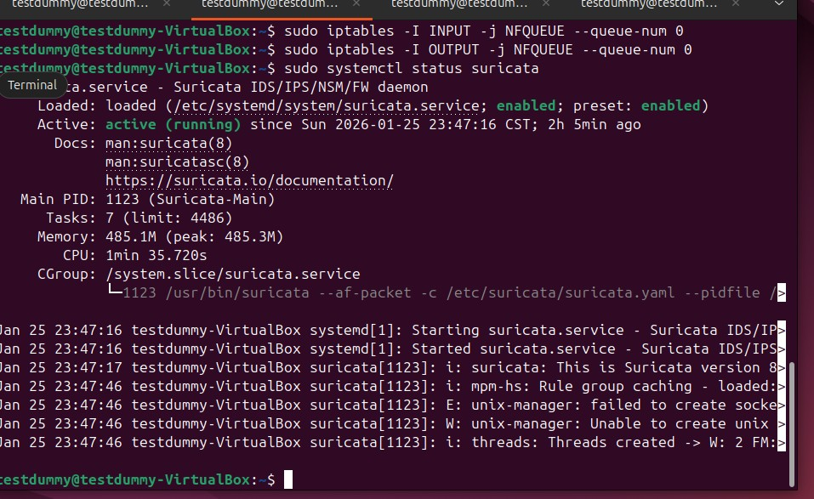
If af packet is still enabled, perform:
sudo systemctl restart suricata
sudo systemctl status suricata
Afterwards the af-packet should be replaced by -q 0
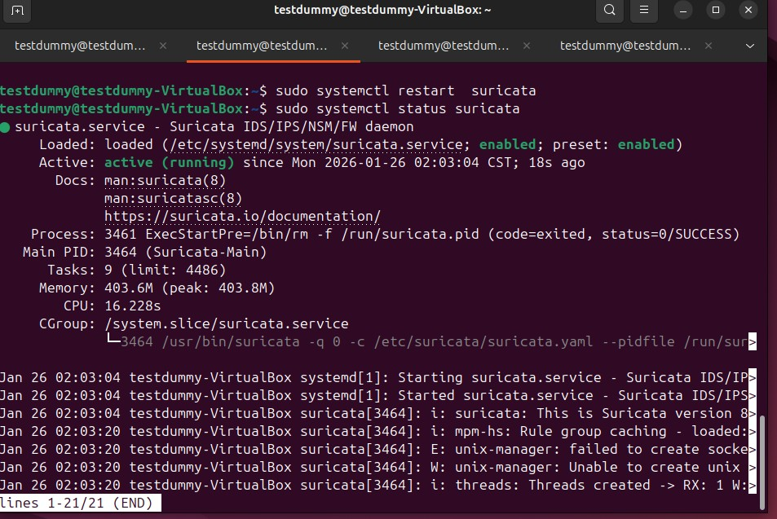

Step 10 — Generate traffic from Kali using hping3 DDoS
sudo hping3 -1 -i u2500 -c 100 10.0.2.4
This command sends Internet Control Message Protocol packets (ping-style traffic) from your Kali machine to the Ubuntu machine at IP address 10.0.2.4.
The -1 option tells hping3 to use ICMP packets instead of TCP or UDP.
The -i u2500 option sets the interval between packets to 2500 microseconds, creating a steady stream of traffic.
The -c 10 option limits the test to 10 packets so it does not run forever.
This traffic should match your custom Suricata rule and trigger an alert or be blocked if IPS mode is working.

What you should see
In your Suricata log terminal (the one running sudo tail -f /var/log/suricata/fast.log), you should see an alert similar to:
Custom ICMP Block Message
This confirms that Suricata detected (and in IPS mode, blocked) the hping3 traffic.

Troubleshooting tip
If nothing appears in the log:
- Confirm Suricata is running with sudo systemctl status suricata.
- Confirm iptables NFQUEUE rule exists with sudo iptables -L.
- Confirm your custom rule file is loaded with
sudo suricata -T -c /etc/suricata/suricata.yaml.

